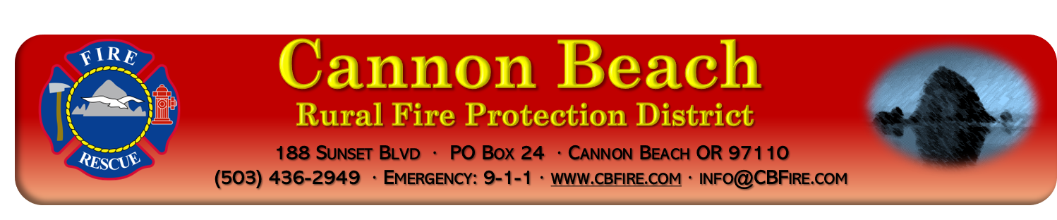
Cannon Beach Rural Fire Protection District
Board of Directors
Regular Meeting July 20, 2026, at 6:00pm
Fire Station Board Room – 188 Sunset Boulevard, Cannon Beach, OR
AGENDA
(posted July 7, 2026
- Approve Agenda
- Public Comments and Correspondence
- Oath of office
  - Bob Cerelli
  - Rick Hudson
- Elect Board officers
  - President
  - Vice-President
  - Secretary/Treasure
- Approve June 8th budget hearing minutes
- Approve June 8th regular meeting minutes
- Approve June 30th special meeting minutes
- Status Reports
  - Finance
  - Call Response
  - Projects
  - Civil Service
- Business Items
  - Arch Cape Station expansion Financing

- Future meeting agenda Items
- Directors Comments
- Adjourn
Public is welcome to join in person or by Zoom.
https://zoom.us/j/96909730187
Meeting ID: 969 0973 0187
+1 253 215 8782 US (Tacoma)
Public comments will be taken at the beginning of the meeting and is limited to three minutes per person.

